Lab # 07



Fall 2024

**CSE-310L Control Systems Lab**

Submitted by: MUHAMMAD SADEEQ

Registration No.: 21PWCSE2028

Section: C

“On my honor, as a student of the University of Engineering and Technology, I have neither given nor received unauthorized assistance on this academic work”

Submitted to:

Dr. Muniba Ashfaq

(1 Dec 2024)

Department of Computer systems engineering

University of Engineering and Technology, Peshawar

**Objectives:**

The objective of this lab is to:

* model the system in time domain.

# State Space Representation:

State Space representation is one of the unified method for modeling, analyzing and designing a wide range of systems.

* 1. **Use the MATLAB code to form an LTI state space representation from the transfer function. The matrix A, B and C are shown below.**

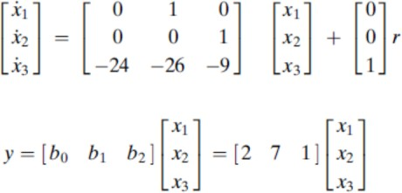

Code:

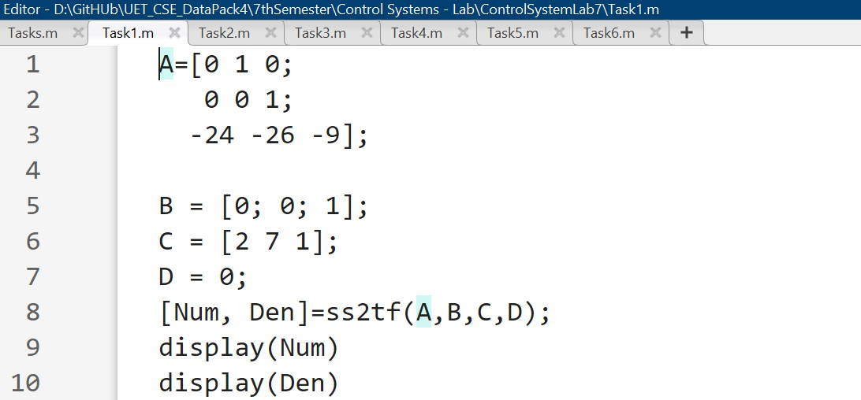

Output:

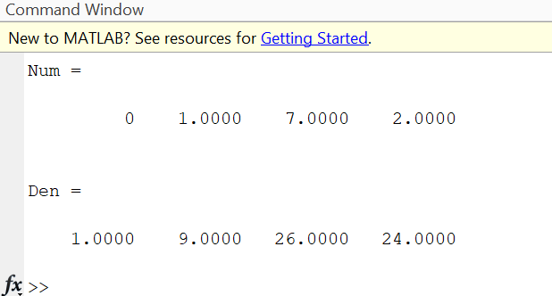

* 1. **Use the MATLAB to convert the state space representation to the transfer function for the following**

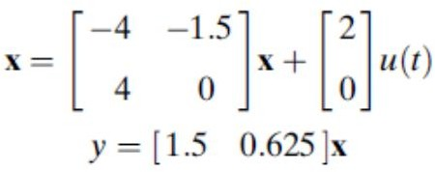

Code:

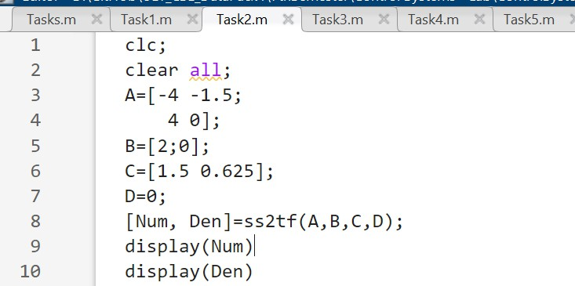

Output:

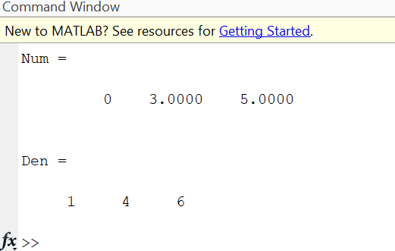

* 1. **Write the MATLAB code for the conversion of transfer function to the state space representation of the following system**

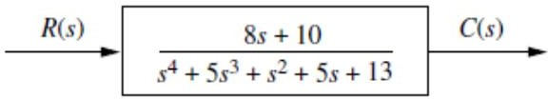

Code:

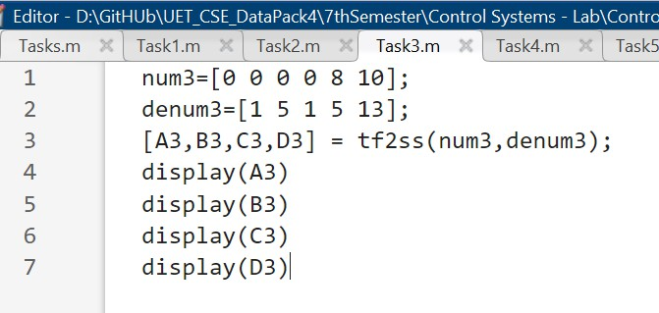

Output:

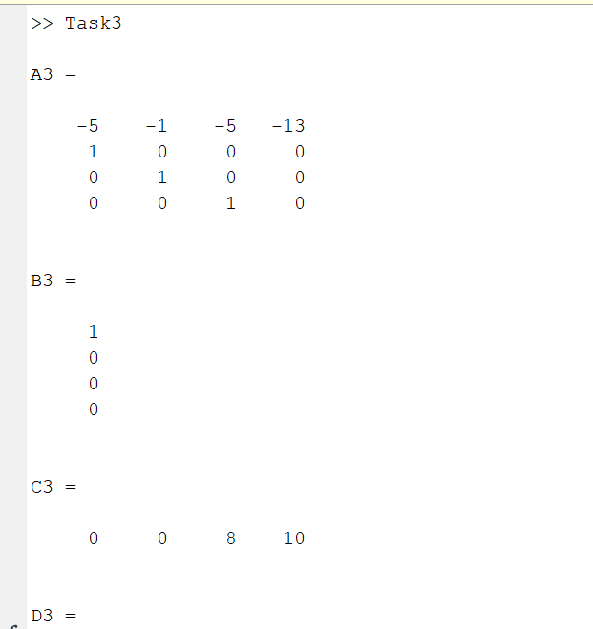

* 1. **Write the MATLAB code for the conversion of transfer function to the state space representation of the following system**

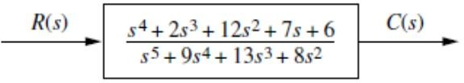

Code:

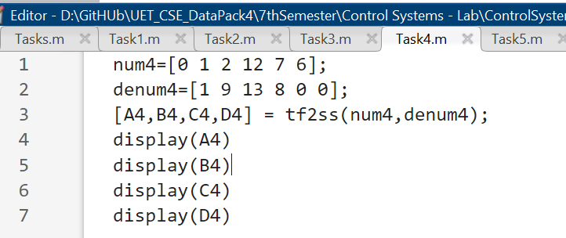

Output:

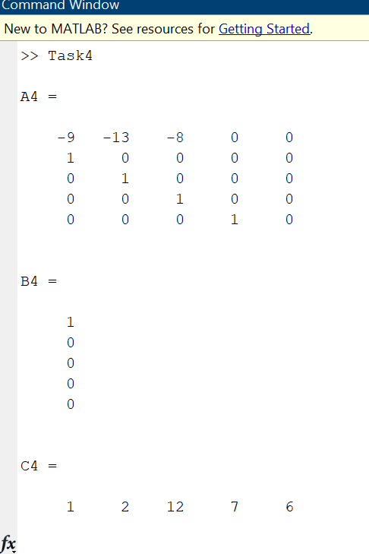

* 1. **Write the MATLAB code for the conversion of state space representation to the transfer function for the following**

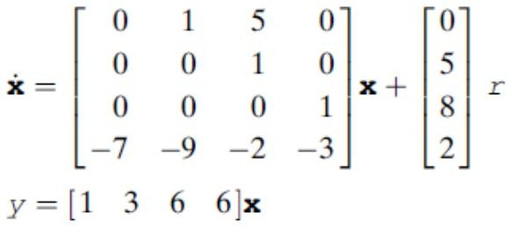

Code:

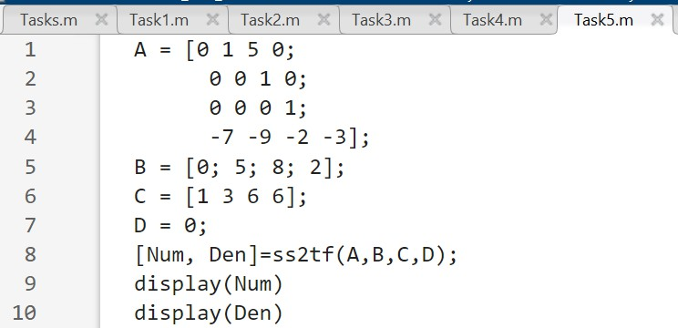

Output:

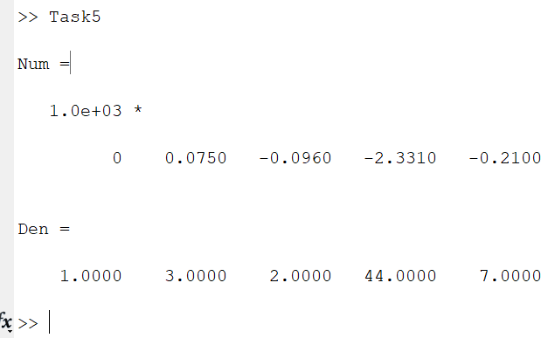

* 1. **Write the MATLAB code for the conversion of state space representation to the transfer function for the following**

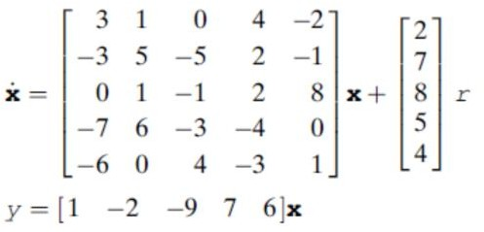

Code:

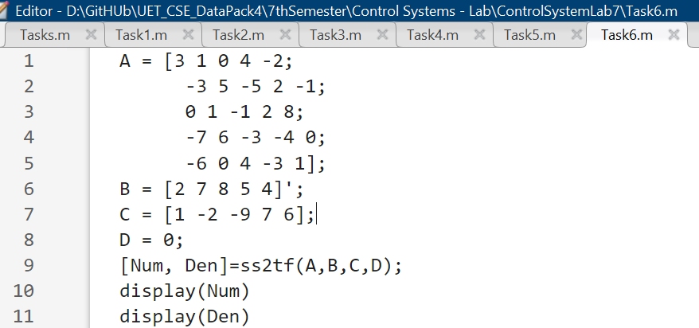

Output:

